Room E

E Q 1 Cholecystectomy Complications
Stem: You are called to the ER to see a 65-year-old man who presents with worsening epigastric and RUQ abdominal pian, 3 days after laparoscopic cholecystectomy for acute, calculous cholecystitis.
Reports, PO intolerance, chills, fevers, jaundice, darkened urine.
He is otherwise without significant past medical or surgical history.
Vitals : HR 114bpm, BP 94/37; 94% on RA, 38.8C
PE: Ill appearing, lethargic, jaundice, scleral icterus Mildly distended, TTP in the RUQ and epigastrium.
labs: WBC 16.4k; Tbili 4.3; AST 143; ALT157; ALK Phos 312; Creatinine 1.73 (normal 0.90)

Stem: You are called to the ED to see a 78 yo man who presents with 3 day history of fevers and chills, sweats and feeling poorly. He reports RUQ abdominal pain and some nausea but no emesis. He is otherwise healthy.
Vitals: T=99.9 degrees, BP=100/60, HR 110, and RR of 20.
Physical exam : Tender to palpation in the right upper quadrant without guarding or peritoneal signs.
Labs: WBC of 18K, LFTs slightly elevated, otherwise rest of labs normal.
PMH/PSH: Diverticulitis. Colonoscopy 1 year ago with diverticulosis

W hat’s the initial study would you like to order now?
RUQ US –dilated intra and extrahepatic bile ducts with CBD measuring 1.1cm, mild RUQ fluid, and distal common bile duct stone.

How are you going to manage this patient.
- Sepsis workup.
- Resuscitation / hydration/ antibiotics.
- ERCP : You are not credentialed to do it and your GI colleague is on vacation.
- PTC: Your IR colleagues are not available
- Urgent CBD exploration:
  - Open CBD Exploration.
  - Kocherize the duodenum, palpation of the common bile duct to assess location/mobility of the stone, exposure of anterior CBD
  - Place sutures at the 10 and 2 positions and make an anterior vertical ductotomy.
  - Flush duct with small diameter red rubber and pass a biliary Fogarty catheter proximally and distally until all stones are removed.
  - Choledochoscope can be used with wire basket to retrieve challenging stones.
  - Close ductotomy over a 14fr T-tube
  - Perform completion cholangiogram.
  - Leave JP drain.

Scenario 2:Same patient arrives, RUQ US notes intra and extra hepatic ductal dilation, mild fluid, no stone is appreciated. You are now in a tertiary center with all images and expertise available.
- ERCP or MRCP or advanced imaging to delineate etiology →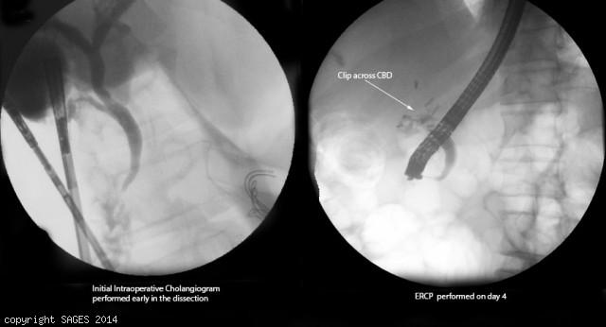
Concern for clip across CBD
- Antibiotics
- IR consultation for PTC.
You take the patient to the OR for repair, how do you repair the following?
- Injury < 50% circumference, not caused by caut ery -Repair over T tube.
- Transection < 1 cm in size and away from bifurcation-End to end anastomosis.
- More severe injury, or close to the bifurcation:Hepaticojejunostomy -- Describe.
  - Identify CBD
  - Place two traction sutures on either side of the dilated bile duct.
  - The distal CBD is ligated.
  - The duct is divided below the traction sutures.
  - The end of the common duct is then trimmed to achieve maximal diameter.
  - fashion a Roux-en-Y jejunal limb
  - This limb is identified and transected with a stapling device 30-35 cm from the ligament of Treitz.
  - A single-layer anastomosis can be performed by a side-to-side anastomosis to the Roux limb
Scenario 3:Same patient however with AST/ALT and Alk phos within normal limits, Tbili slightly elevated to 2.4. RUQ US shows concern for large fluid collection in the RUQ.
1. HIDA:Shows biliary leak.
2. ERCP obtained →cystic duct stump leak confirmed →Sphincterotomy and Stent
3. IR for drainage of RUQ fluid collection if symptoms do not resolve, persistent leakage or septic.

